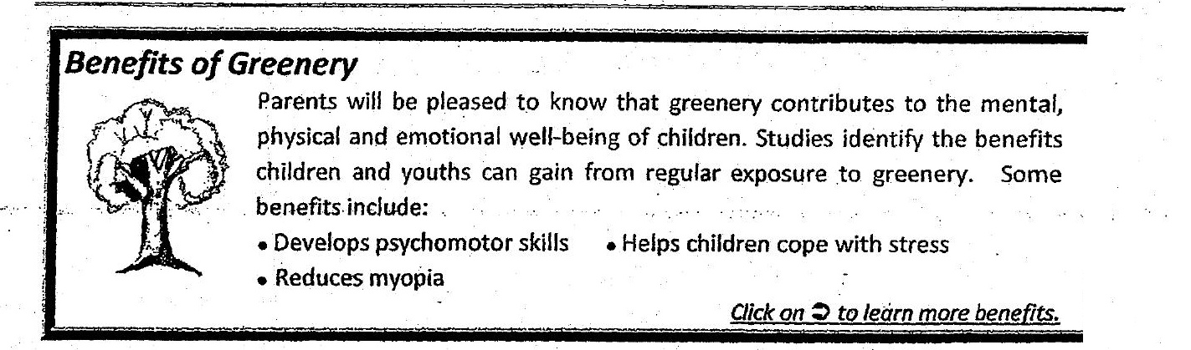



To be a volunteer, email us at volunteerwithus@npc.sg.  
For general enquiries, email us at enquiries@npc.sg or call our hotiine at 6303 6666.  
ra nn ern rt